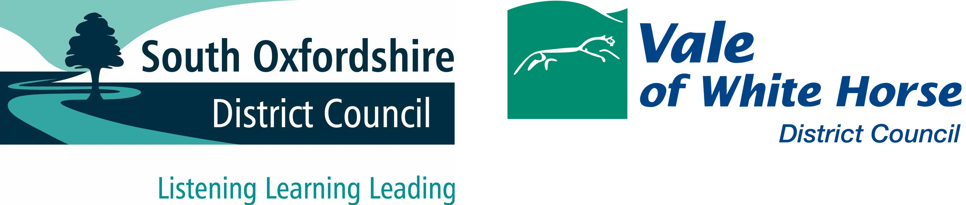

Legionella Policy

Last updated: October 2023

Contents Page
Policy statement 3

Aims of Policy 3

Implementation 4

Training 4

Resident Involvement 4

Monitoring and Review 4

Useful Definitions:

The Councils – Refers to the South Oxfordshire District Council and Vale of White Horse District Council.
Landlord – This will be the named Landlord on the Tenancy Agreement and will be either South Oxfordshire District Council OR Vale of White Horse District Council
The Service Provider – This means the appointed sub-contractor for the Councils who will implement the terms of the Policy. As of 30 October 2023, this will be Soha Housing.
Tenant/s – Person/s who occupy the property which is owned or leased by the Landlord.

Legionella Policy
Policy Statement
- The aim of this document is to set out The Councils approach to the management of Legionella bacteria in our water systems within the stock owned and leased by us, to staff, residents, contractors and the public dealing with water and water systems in our homes.

- The Service Provider will take all appropriate steps to comply with the relevant legislation and guidance.

- The Service Provider will take all reasonable and practical measures to prevent the exposure of employees, tenants and members of the public to legionella bacteria when visiting, living and/or working within any properties owned or rented by The Councils.

- The Service Provider will keep a log of all locations of communal stored water systems and the associated risk assessments.

- The Service Provider will take measures to prevent exposing staff, contractors or the public to legionella bacteria through the provision of information, training (where appropriate), instruction and where necessary supervision.

- All staff will follow defined, detailed procedures where work is carried out on their water systems.

Aim of the Policy
- The aim of this Policy is to manage our statutory obligations in relation to Legionella and comply with the Approved Code of Practice L8, Health and Safety at Work Act 1974, Control of Substances Hazardous to Health 2002 and the Management of Health and Safety at Work Regulations 1999. In doing so The Service Provider is able to protect The Councils housing, its employees, contractors, tenants and the general public from accidental exposure.

- Legionella is potentially a significant risk for The Councils. This policy is designed to mitigate the risks posed by Legionella which includes an outbreak of Legionnaires disease, the threat of legal action, adverse publicity etc.

- In order to control the risk of accidental exposure, The Service Provider will (through competent Contractors): Identify and assess the risk of Legionella bacteria in water systems, devise a scheme for eliminating or controlling the risk, manage the risk, select and train competent personnel and keep up to date records through electronic and logbook data capture.

- The Service Provider will apply their Legionella policy consistently and fairly and will not discriminate against any person on grounds of their race, colour, ethnic or national origins, religion, sexual orientation, disability, gender, age. The Service Provider will promote inclusion and challenge discrimination.

Implementation
- Only approved competent contractors will undertake works on water systems according to the requirements of the relevant statutory legislation, approved codes of practice and guidance.

- After any testing of communal water systems, the results will be recorded electronically by the Contractor. All remedial works required will be notified to The Service Provider by the contractor in accordance with agreed timescales.

Training
- Any employees who are engaged in activities that support water safety management will receive training in accordance with the requirements laid out in relevant guidance and according to job role and its associated activities.
Resident Involvement
- This Policy directly affects the safety of tenants in their homes. The Service Provider will raise tenants’ awareness of Legionella within publications and on the website.
Monitoring and Responsibility
- The Head of Service for The Councils has overall responsibility for implementation of this policy. All employees must comply with health & safety procedures at all times.

- The Service Provider will ensure, through risk assessments and ongoing monitoring the necessary requirements to maintain water safety. This will be in partnership with specialist competent contractors.

- Context
This Policy is based on current legislation and best practice. The Councils will amend it in line with any changes.

