East Hagbourne Parish Neighbourhood Development Plan – Post Adoption Statement in accordance with the Environmental Assessment of Plans and Programmes Regulations 2004 and European Directive 2001/42/EC

04 APRIL 2023

**1 Introduction**

**1.1 The Neighbourhood Development Plan**

The East Hagbourne Neighbourhood Development Plan (NDP) was ‘made’ (adopted) by South Oxfordshire District Council (the District Council) on 11th April 2019 and now forms part of the South Oxfordshire Development Plan for the determination of planning applications in the Parish.

In preparing the NDP, account was taken of the requirements of European Union Directive 2001/42/EC on the assessment of the effects of certain plans and programmes on the environment, referred to as the Strategic Environmental Assessment (SEA) Directive and its transposing regulations, the Environmental Assessment of Plans and Programmes Regulations 2004 (the SEA Regulations).

The SEA Directive and transposing regulations seek to provide a high level of protection of the environment by integrating environmental considerations into the process of preparing certain plans and programmes. The aim of the Directive is *“to contribute to the integration of environmental considerations into the preparation and adoption of plans and programmes with a view to promoting sustainable development, by ensuing that, in accordance with this Directive, an environmental assessment is carried out of certain plans and programmes which are likely to have significant effects on the environment*.”

In developing the NDP, proportionate, robust evidence should support the choices made and the approach taken. In terms of SEA and Sustainability Appraisal (SA), the Planning Practice Guidance (PPG) (paragraph 26, SEA and SA) states:

“*There is no legal requirement for a neighbourhood plan to have a sustainability appraisal as set out in section 19 of the Planning and Compulsory Purchase Act 2004. However, a qualifying body must demonstrate how its plan or order will contribute to achieving sustainable development. A sustainability appraisal may be a useful approach for doing this*.”

Paragraph 27, SEA and SA of the PPG continues:

“*In some limited circumstances, where a neighbourhood plan is likely to have significant environmental effects, it may require a strategic environmental assessment. Draft neighbourhood plan proposals should be assessed to determine whether the plan is likely to have significant environmental effects*.”

Consistent with this guidance, the District Council completed a SEA Screening Opinion (8 June 2016). This concluded that the NDP, as then proposed, was unlikely to have significant effects on the environment and that an SEA was not required. Subsequently, the NDP was revised to include an allocation of land for development. Consequently, an SEA was undertaken by Mark Fessey of AECOM Infrastructure & Environment UK Ltd on behalf of East Hagbourne Neighbourhood Plan Steering Group, representing East Hagbourne Parish Council who are the qualifying body, and comprising of:

* A Scoping Report dated February 2018
* An Environmental Report dated February 2018
* An Environmental Report Update: Non-technical Summary dated February 2018
* An Environmental Report Update dated September 2018
* An Environmental Report Update: Non-technical Summary dated September 2018

The reports can be viewed at: <http://www.southoxon.gov.uk/EastHagbourne-NP> and <https://easthagbourne.net/parish-council/neighbourhood-plan/>

This Post Adoption Statement represents the conclusion of the SEA process and fulfils the plan and programme adoption requirements of the SEA Directive and SEA Regulations. This statement has been prepared in accordance with Regulation 16 (3) and (4) of the Environmental Assessment of Plans and Programmes Regulations 2004, which require a statement to be produced on adoption of a plan or programme, to detail, in summary:

* how environmental considerations have been integrated into the NDP (Section 2 of this document);
* how the Environmental Report has been taken into account (Section 3);
* how opinions expressed in response to the consultation on the Draft NDP and Draft Environmental Report have been taken into account (Section 4);
* the reasons for choosing the NDP, as made, in the light of the other reasonable alternatives dealt with (Section 5); and
* the measures that are to be taken to monitor the significant environmental effects of the implementation of the NDP (Section 6).

**2 HOW ENVIRONMENTAL CONSIDERATIONS HAVE BEEN INTEGRATED INTO THE NDP**

**2.1 Environmental Considerations in the NDP**

### Preparation of the NDP

Environmental and wider sustainability considerations have been integral to the key decisions made in respect of the policies and proposals of the NDP. The integration of these considerations into the plan making process has principally been achieved through:

* the development of a proportionate evidence base on topics including (inter alia) housing, population and health, transport, landscape, air quality, biodiversity, flood risk, climatic factors;
* engagement with key stakeholders and the public on the emerging NDP and related environmental and sustainability matters;
* the consideration of national planning policy and the objectives of other plans and programmes, including those produced by the District Council; and
* ongoing assessment including SEA (see **Section 2.2**).

### NDP Content

The NDP plans positively to support local development (as outlined in paragraph 13 of the National Planning Policy Framework). This aim is expressed in the NDP Vision, which is: "To safeguard the individual character, vitality and community facilities of our historic village and protect its rural environment for the health and wellbeing of town and village residents alike, whilst supporting sustainable development that meets the needs of residents now and in the future."

The Vision is supported by 12 Objectives in the NDP which are as follows:

|  |  |
| --- | --- |
| **SUSTAINABLE DEVELOPMENT** | |
| SD1 | Support sustainable development that meets the needs of residents now and in the future. |
| **VILLAGE CHARACTER** | |
| VC1 | Preserve the independent and rural character of our village as Didcot expands. Conserve and enhance key views both into and out from the built areas and within the built areas |
| VC2 | Conserve and enhance the heritage of the historic core of the village within and adjoining the Conservation Area together with its Listed Buildings and structures. |
| VC3 | Protect the village envelope and surroundings from light pollution |
| **HOUSING** | |
| H1 | Respond to housing needs of residents and provide a proportionate contribution to meet SODC’s housing requirements |
| **COMMUNITY** | |
| CF1 | Ensure that village infrastructure and facilities support village life now and into the future. |
| **TRANSPORT AND ACCESS** | |
| TA1 | Maintain and improve road safety for all road users. |
| TA2 | Promote mobility and maintain or enhance the quality of pavements without creating an urban appearance. |
| TA3 | Ensure that new development does not add to the problem of on-street parking. |
| **GREEN SPACE, ENVIRONMENT AND CONSERVATION** | |
| E1 | Maintain and enhance green spaces for the health and wellbeing of the community |
| E2 | Maintain and enhance biodiversity |
| E3 | Protect housing from flooding |

The NDP contains a number of policies to help realise the Vision and Objectives and help to deliver sustainable development.

Policy SD1 directly addresses sustainable development, highlighting 9 specific areas where planning applications are expected to contribute, as appropriate, to sustainable development. Policies VC1a-c define three "Local Gaps" important to the distinctive character of East Hagbourne. VC2 addresses views, while VC3 promotes good design and VC4 identifies assets of local distinctiveness. Together these contribute to protecting the landscape and character of the NDP area, while VC5 specifically addresses heritage assets. VC6 addresses street lighting which is important for residents' health and wellbeing.

Policies H1-H3 address housing needs and allocates a development site which exceeds the expectations of the Local Development Plan for a smaller village and will be supplemented by infill development. Policies CF1 & CF2 require new developments to provide sufficient infrastructure and to avoid harming important community facilities, while Policies TA1-TA3 address traffic and road safety including encouraging sustainable modes of transport.

Policies E1-E3 address green spaces and environment, with E1 designating five areas within the village as Local Green Spaces. Policy E2 requires new developments to protect and enhance biodiversity and the natural environment and E3 addresses the risk of flooding in this low-lying area, an issue which is becoming more important as a result of climate change.

**2.2 Environmental and Sustainability Considerations in the SEA**

To provide the context for the SEA, and in compliance with the SEA Directive, a proportionate review of other relevant plans and programmes was undertaken and the relevant aspects of the current state of the environment and its evolution without the NDP were considered; together, they informed the identification of a series of key sustainability issues. This information was set out in the Scoping Report (2018) and informed the Environmental Report.

The key sustainability issues identified through the review of plans and programmes and analysis of baseline information as important for the East Hagbourne Neighbourhood Development Plan, informed, and were reflected in, the objectives and criteria that comprised the framework used to appraise the NDP (the SEA Framework) (see **Table 2.1)**. Broadly, the SEA objectives presented the preferred sustainability outcome which usually involved minimising detrimental effects and enhancing positive effects.

**Table 2.1: The SEA Framework**



The SEA process considered the contribution of the NDP towards each of the appraisal objectives, drawing on the baseline information to predict the likely significant effects in line with the Office of the Deputy Prime Minister (now Ministry of Housing, Communities and Local Government) Practical Guide to the SEA Directive[1]. Specifically, the following key components of the NDP were appraised against the SEA objectives:

* Policies in the NDP;
* Housing growth scenarios;
* Site allocation options (including reasonable alternatives).

The appraisal identified the likely changes to the baseline conditions as a result of the NDP’s implementation. These effects were described (where possible) in terms of their extent, the timescale over which they could occur, whether the effects would be temporary or permanent, positive or negative, short, medium and/or long-term. The potential for secondary, synergistic and cumulative effects were also considered and reported where relevant.

**3** **HOW THE ENVIRONMENTAL REPORT HAS BEEN TAKEN INTO ACCOUNT**

**3.1 Overview**

The development of the NDP has been iterative and has benefitted from extensive consultation and advice from SODC. SEA has played an integral role in this iterative process with each of the following NDP stages having been accompanied by an Environmental Report in order to help inform the Plan and fully integrate environmental and sustainability considerations into decision making. **Table 3.1** below lists the iterations of the NDP, corresponding Environmental Reports and key conclusions from the Environmental Report

**Table 3.1 Summary of SEA Iterations**

|  |  |  |
| --- | --- | --- |
| Report | Summary of the Accompanying SEA Environmental Report (what was appraised) | Key Conclusions from the SEA Environmental Report |
| SEA Screening Statement 6 June 2016, (performed by SODC). | The Screening Statement addressed the proposed NDP as it was envisaged at that time, which did not include site allocations for housing. | The East Hagbourne NDP is unlikely to have significant effects on Natura 2000 sites, therefore, an Appropriate Assessment for the Example Neighbourhood Development Plan is not required.  Based on the assessment presented in Appendices 1 & 3, the East Hagbourne NDP is not likely to have a significant effect on the environment.  The East Hagbourne NDP does not require a Strategic Environment Assessment. |
| Strategic Environmental Assessment (SEA) of the East Hagbourne Neighbourhood Plan.  Scoping Report, February 2018.  (Performed by AECOM) | In August 2017, it was decided, in consultation with SODC, to include an allocation of land for housing in the Plan.  AECOM reviewed the draft Plan and provided general comments on the soundness of the process. | Comments were received from AECOM in the preparation of the Scoping Report, which resulted in changes to the suitability criteria to make them more objective.  The final Scoping Report did not provide consolidated conclusions, but gave comments and defined objectives and appraisal questions under eight topic headings:   * Air Quality. * Biodivertity * Climate change * Landscape & Historic Environment * Land, Soil and Water Resources * Population & Community * Health & Wellbeing   Transportation |
| * Strategic Environmental Assessment (SEA) of the East Hagbourne Neighbourhood Plan * Environmental Report February 2018   (including a non-technical summary)  (Performed by AECOM) | This version of the SEA was prepared for the Reg 14 consultation to assess the draft plan and proposed site options. | The SEA assessed the shortlisted site allocation options and concluded that allocation of just one site was preferable to allocating two sites, because "allocation of both sites (Option 2) would lead to a range of concerns over and above Option 1, most notably in respect of landscape and loss of best and most versatile agricultural land"  The Parish Council supported this conclusion.   * The SEA also assessed the policies in the proposed submission Plan and found them broadly positive - the conclusions for each topic area are outlined in section 5. |
| Strategic Environmental Assessment (SEA) of the East Hagbourne Neighbourhood Plan  Environmental Report Update: September 2018  (including a non-technical summary)   * Performed by AECOM | This Assessment reviewed the NDP immediately prior to its submission to SODC and commencement of the Reg 16 consultation | The SEA updated the assessment of February 2018, taking into account the changes made to the policies in the NDP as a result of the consultation.  The evaluation of the site assessment remained unchanged.  Additional comments were made on the policies, but the conclusions on their impact of the topic areas outlined in section 5 remained broadly unchanged. |

**3.2 How the Findings of the SEA Have Been Taken into Account**

The SEA has helped provide confirmation that the shape and direction of the NDP, guided by extensive consultation with SODC, was robust.

In particular, the findings of the SEA of the emerging NDP and reasonable alternatives have informed decisions in respect of:

* Improving the site assessment process to ensure it was robust and objective.
* Options for delivering the overall amount of growth required and the final choice for the site to be allocated in the NDP.

The SEA did not make any specific recommendations with respect to the policies of the NDP, but confirmed that they were broadly positive (see Section 5). It concluded that:

* The Plan is predicted to result in ‘significant positive effects’ in terms of heritage, landscape and residents needs / community / housing mix.
* The extent of the effects depends on how many housing developments take place within the NDP area.
* The Plan also performs well in terms of ‘housing’ in the sense that the proposal is to allocate the Greenlight site (Site 5), and thereby proactive support the timely delivery of that site.
* There is little or no reason to suggest that any policies in the plan, or the policies acting in combination, are in any way contrary to the achievement of housing objectives.

Through the SEA, a number of recommendations were also made concerning the emerging plan policies and these were set out in the Environmental Reports prepared in support of earlier drafts of the NDP. The recommendations are summarised in **Table 3.2** together with a commentary on whether or not these were reflected in the made NDP and, if so, how.

**Table 3.2: Recommendations arising from the SEA**

|  |  |
| --- | --- |
| Recommendation | Response |
| Policy might be established that seeks to ensure that development of the site addresses… car parking in the area of the Village Hall and School to minimise congestion at peak times | The submission version of the plan now includes a list of site specific criteria for the Greenlight site, two of which relate to parking |
| Consider the potential for a policy requirement to supplement the emerging Local Plan policy in respect of agricultural land quality, on the basis that the great majority of agricultural land potentially suitable for development surrounding the village is of ‘best and most versatile’ (BMV) quality. | The Parish Council recognises that policy would ideally be in place, but has concluded that there is insufficient evidence available. Were evidence available to show how agricultural land quality varies from field to field, or broader land parcel to land parcel, then a policy that seeks to protect the highest quality land would be very welcomed. |

**4 HOW OPINIONS EXPRESSED DURING CONSULTATION HAVE BEEN TAKEN INTO ACCOUNT**

**4.1 Overview**

The development of the NDP has been informed by extensive, ongoing engagement and public consultation, in accordance with the Neighbourhood Planning (General) Regulations 2012 (SI No. 637).

A Consultation Statement was prepared for the NDP in accordance with Paragraph 15 (2)1 of the Regulations which defines a “consultation statement” as a document which:

*(a) contains details of the persons and bodies who were consulted about the proposed neighbourhood development plan;*

*(b) explains how they were consulted;*

*(c) summarises the main issues and concerns raised by the persons consulted; and*

*(d) describes how these issues and concerns have been considered and, where relevant, addressed in the proposed neighbourhood development plan.*

The Consultation Statement sets out the consultation undertaken during the preparation of the NDP, a summary of main issues raised and details of how the comments received have been taken into account.

**4.2 SA Consultation Summary**

Following consultation on the scope of the SEA, Environmental Reports have been prepared and published for consultation at each key NDP stage as set out **Table 3.1** above.

A five week consultation was undertaken on the Scoping Report which concluded the end of January 2018; a total of 4 responses were received.

Natural England

In our review of the East Hagbourne Neighbourhood Plan Strategic Environmental Assessment (SEA) scoping report we are satisfied with the scope and contents of the proposed SEA.

Historic England

We would expect the Scoping Report to set out the indicators or measures by which the policies and proposals of the Plan can be assessed against the objectives and sub-objectives. The Historic England advice on Strategic Environmental Assessments and the Historic Environment contains a range of possible indicators for assessing and monitoring the performance of the policies and proposals of the Plan against a historic environment objective. Not all of these will be relevant, but we suggest that the following be considered:

* the number and percentage of different heritage assets at risk;
* the percentage of planning applications where archaeological investigations were required prior to approval; and
* the percentage of planning applications where archaeological mitigation strategies were developed and implemented.

Environment Agency

Thank you for consulting the Environment Agency on the scoping report for the East  
Hagbourne Neighbourhood Plan. We are a statutory consultee in the SEA process and  
aim to reduce flood risk and protect and enhance the water environment. Based on our  
review of the draft scoping report, we think the following environmental issues should be  
included to ensure the neighbourhood plan adequately assesses any environmental  
impact:

Flood risk  
The Neighbourhood Plan includes areas of flood zone 2 and 3, specifically through East  
Hagbourne adjacent to the Hakka’s Brook, and to the south of the plan area near  
Hagbourne Mill Farm and Hagbourne Moor. It is not clear whether the plan intends to  
allocate sites for development. We note the advice in paragraph 1.5 of your scoping  
statement that although there are no specific allocations for housing for this plan area  
through the emerging local plan, a certain number of homes will be delivered in the  
“smaller villages” over the duration of the plan, and that this will be achieved through  
Neighbourhood Plans which allocate sites. If there is any intention to allocate sites for  
development in this plan, then we advise that the Local Authorities Strategic Flood Risk  
Assessment and Surface Water Management Plans are the evidence documents which  
will need to be consulted to determine the level of flood risk in this area. We expect the  
Sustainability Appraisal to include flood risk in the baseline information, as a key  
sustainability issue and as an objective.

Main river  
The Hakka’s Brook, Mill Brook and West Hagbourne Stream run through the  
neighbourhood plan area. These watercourses are currently failing to reach good  
ecological status/potential under the Water Framework Directive (WFD). They are  
within the WFD catchment known as Mill Brook and Bradfords Brook system  
(Wallingford). This catchment is currently classified as having moderate status.  
Developments within or adjacent to these watercourses should not cause further  
deterioration and should seek to improve the water quality based on the  
recommendations of the Thames River Basin Management Plan. An assessment of the potential impacts of the neighbourhood plan on this watercourse under WFD should be  
included within the SEA/SA appraisal.

You should consider the requirements of the WFD and recommendations from the  
Thames River Basin Management Plan in your SA, as an SA objective against which  
your plan will be appraised and as part of your baseline.

Oxfordshire County Council

Oxfordshire County Council does not normally comment on draft SEA Scoping reports for neighbourhood plans.  Nevertheless, I have had a quick look through and it seems that you have prepared a thorough report.  I understand that the East Hagbourne neighbourhood plan group are considering preparing a neighbourhood plan with allocations and therefore the work will continue.  We normally provide comment when a draft neighbourhood plan is produced.

One thing I did note from my quick read was the comment: ‘The Neighbourhood Plan area is not connected to the rail network. The nearest railway station is located approximately 2.5km to the north in the neighbouring parish of Didcot…’  Perhaps the sentences could be reworded to more usefully record that parts of the neighbourhood plan area are quite close to Didcot Parkway Railway Station (as close as xxkm) whereas the most distant parts are up to xxkm away.

The draft Environmental Report accompanying the Regulation 14 (Pre-submission version of the NDP) was consulted on for 6 weeks which concluded on 14th April 2018 a total of 87 responses were received.

The comments received addressed the NDP policies and supporting text and changes to the NDP were made as a result. The comments did not directly address the Environmental Report.

Details of the results of consultation at this stage are comprehensively reported in the Consultation Report, available at:

<http://www.southoxon.gov.uk/EastHagbourne-NP>

1. **THE REASONS FOR CHOOSING THE NDP, AS ADOPTED, IN THE LIGHT OF THE OTHER REASONABLE ALTERNATIVES DEALT WITH**

**5.1 Overview**

Article 5 (1) of the SEA Directive and SEA Regulation 12(2) require that “*an environmental report shall be prepared in which the likely significant effects on the environment of implementing the plan or programme, and reasonable alternatives taking into account the objectives and the geographical scope of the plan or programme, are identified, described and evaluated*”. Information to be provided includes “*an outline of the reasons for selecting the alternatives dealt with*” (SEA Directive Annex I (h) and SEA Regulations Schedule 2 (8)).

The European Commission guidance on the SEA Directive[2] discusses possible interpretations of handling ‘reasonable alternatives’ as required by Article 5(1). It states that “*The alternatives chosen should be realistic. Part of the reason for studying alternatives is to find ways of reducing or avoiding the significant adverse effects of the proposed plan or programme*”.

As set out in **Section 3**, the SEA has been an iterative process undertaken alongside and integrated with the development of the NDP itself. The reasonable alternatives considered in preparing the NDP and appraised through the SA have related to :

* development scenarios (the amount of growth to be accommodated in the plan area);
* site allocations; and
* policies.

The findings of the appraisal of the preferred approach and reasonable alternatives were reported in the Environmental Reports at each stage of NDP preparation and subject to consultation with the wider community and relevant consultation bodies.

**5.2 The Reasons for Choosing the Preferred Approach and for Rejecting Reasonable Alternatives**

The target for new housing in the life of the NDP was set considering the expectations of the Local Development Plan. A site assessment was carried out for all available land parcels in the NDP area with a view to locating land for up to 75 houses. After a first screening exercise, a shortlist of six sites was identified. These were subjected to a more systematic, criteria-based assessment. Assessments were primarily carried out based on the intrinsic characteristics of the site, regardless of any planning proposal that may have been made; however, where proposals existed, these were acknowledged through three supplementary criteria. Two sites were identified that could potentially deliver the required housing numbers and these formed the basis for the "Reasonable Alternatives".

The Final Environmental Report sets out the reasons for choosing the preferred approach and for rejecting reasonable alternatives, this is summarised below.

**Policies Included in the NDP**

Neighbourhood plans are not obliged to contain policies addressing all types of development. The range and scope of policies to be included in the NDP was considered through production of draft versions of the NDP. Relevant policy areas and the SEA findings are summarised below.

The SEA reviewed the policies of the NDP and concluded that

The Plan performs well in terms of biodiversity

The plan may help to minimise per capita emissions from the built environment and from transport; however, effects will be minor, and certainly will not be ‘significant’, recognising that climate change is a global issue.

On flooding, the plan performs very well, with flood risk a clear focus of the plan.

For heritage, the plan performs very well, with heritage a clear focus of the plan.

For landscape, the plan performs very well, with landscape a clear focus of the plan.

With respect to the efficient and effective use of land, the effects of the plan are somewhat neutral,

For waste, the effects of the plan are somewhat neutral.

With respect to use and management of water resources, the plan may lead to some positive effects; however, it is not possible to conclude ‘significant’ positive effects, recognising no potential to assume further major development in the plan period, over-and-above the baseline

With respect to residents' needs, the plan performs very well, with ‘residents needs’ clearly a main focus of the plan. Policies are proposed that should helpfully supplement the emerging policies of the South Oxfordshire Local Plan. It is appropriate to conclude the likelihood of significant positive effects.

With respect to community, ‘community’ clearly a main focus of the plan.

For housing, the plan performs well on the basis that:

A) the Greenlight site is allocated, and thereby proactively supported; and

B) policy specifies local priorities in respect of housing mix. Significant positive effects are predicted, on the assumption that there remains the potential to influence the housing mix at the Greenlight site.

For health, the plan performs very well; however, it is not possible to conclude ‘significant’ positive effects, recognising the wide ranging nature of health determinants (i.e. recognising that that many determinants are largely unrelated to planning).

On promoting sustainable transport and reducing the need to travel, the plan performs well; however, it is difficult to conclude significant positive effects, recognising no potential to assume further major development in the plan period, over and above the baseline.

The SEA evaluated all these policies and determined that the range of policies in the NDP covered community needs as identified in a Community Survey.

**Development Scenarios and Site Options**

The emerging Local Plan (Policy H8) envisages that smaller villages such as East Hagbourne will be expected to deliver 5% to 10% growth over the plan period to 2033. The Parish comprises 500 dwellings, which means a need for up to 50 additional homes. Recognising the high demand for housing in the area, the NDP determined to set a higher target of 75 dwellings.

The first step involved ‘screening’ all land within the parish, with a view to identifying a shortlist of potential site options for further consideration. To facilitate the screening exercise, land within the parish was divided into ten landscape areas, and then further subdivided to give a total of 53 land parcels for evaluation.

Drawing upon an established ‘toolkit’ (Locality, 2015), and in discussion with SODC, the following screening criteria were developed and applied to the evaluation of the 53 parcels:

- Is the site closely related to, and well integrated with the village?

- Is the site easily accessible to EH services and facilities by both roads & footpaths?

- Does the site flood or could it create flooding /environmental issues?

- Will development impact the Conservation Area or the setting of the AONB?

As a result of the screening exercise, six sites emerged as warranting detailed assessment.

The six shortlisted sites were subjected to more systematic, criteria-based assessment. Assessments were primarily carried out based on the intrinsic characteristics of the site, regardless of any planning proposal that may have been made; however, where proposals existed, these were acknowledged through three supplementary criteria.

Ultimately the decision was reached that, in addition to the Greenlight site with outline planning permission, there is one other site that might be considered for allocation. This site is ‘Orchestra’ (otherwise known as East Tadley Field A, 78 homes).

In light of these considerations, the following two housing growth scenarios were established for assessment -

1) Allocate Greenlight only (74 homes) only

2) [Allocate both Greenlight](https://magic.defra.gov.uk/MagicMap.aspx) (74 homes) and Orchestra (up to 78 homes)

SA conclusion:

The broad conclusion is that allocation of both sites (Option 2) would lead to a range of concerns over-and above Option 1, most notably in respect of landscape and loss of best and most versatile (potentially ‘grade 1’) agricultural land. It is fair to conclude that allocation of both sites (Option 2) is supported in respect of ‘housing’ objectives; however, this is not a clear cut conclusion, as there is evidence to suggest that local housing needs (i.e. needs arising from the Parish) would be met under Option 1.

The Parish Council supported the conclusion that Option 1 was more sustainable and the Plan allocated the Greenlight site.

1. **THE MEASURES THAT ARE TO BE TAKEN TO MONITOR THE SIGNIFICANT ENVIRONMENTAL AND SUSTAINABILITY EFFECTS OF THE IMPLEMENTATION OF THE NDP**

**6.1 Overview**

The SEA Regulations (17 (1)) set out that “*The responsible authority shall monitor the significant environmental effects of the implementation of each plan or programme with the purpose of identifying any unforeseen adverse effects at an early stage and being able to undertake appropriate remedial action*”.

The District Council is the responsible authority for the purposes of monitoring the NDP. Planning Practice Guidance states:

“*Monitoring the significant effects of the implementation of a neighbourhood plan that was subject to a strategic environmental assessment should be undertaken (see regulation 17 of the Environmental Assessment of Plans and Programmes Regulations 2004). This will enable unforeseen adverse effects to be identified at an early stage and to enable appropriate remedial actions. The local planning authority should consider arrangements to monitor the significant effects of implementing the neighbourhood plan and reporting this issue in its Monitoring Report*.”

The Local Plan contains a number of monitoring indicators that cover the topics identified in the SEA Directive. These will be used to monitor the effects of the Development Plan, including the East Hagbourne NDP. Appendix A of this document sets out the monitoring indicators for the Local Plan. The Council’s Authority Monitoring Plan will be produced annually with information updated as it becomes available

East Hagbourne Parish Council is not obliged to produce additional indicators for monitoring at the local level but may do so if it wishes. The Qualifying Body would be responsible for monitoring any additional indicators. In this instance the East Hagbourne Parish Council has not elected to do so.

**APPENDIX A: MONITORING INDICATORS FOR THE LOCAL PLAN**

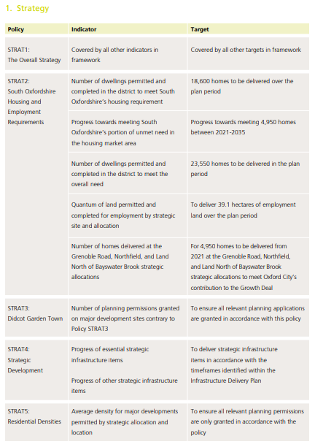

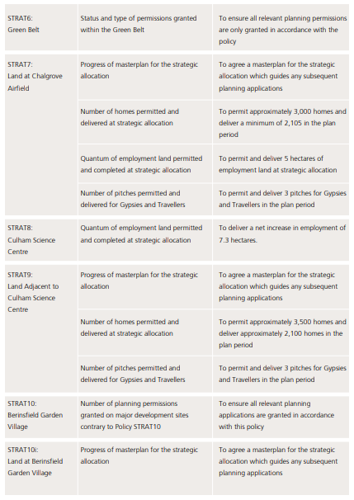

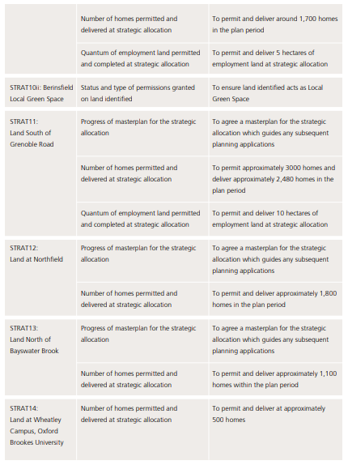

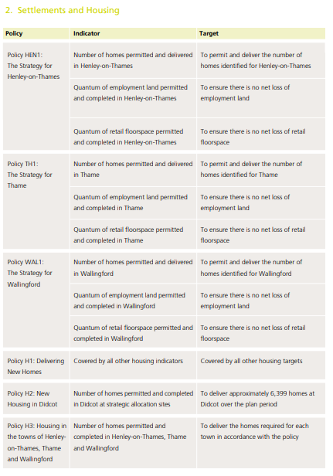

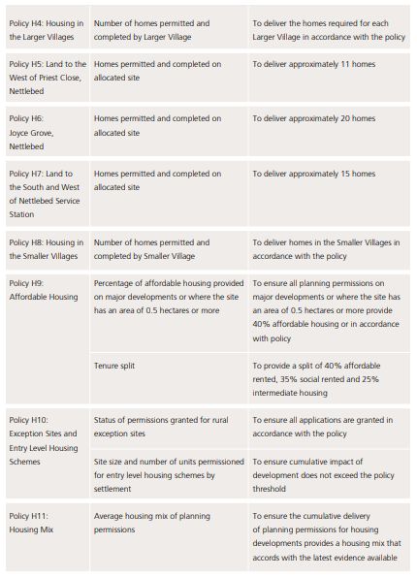

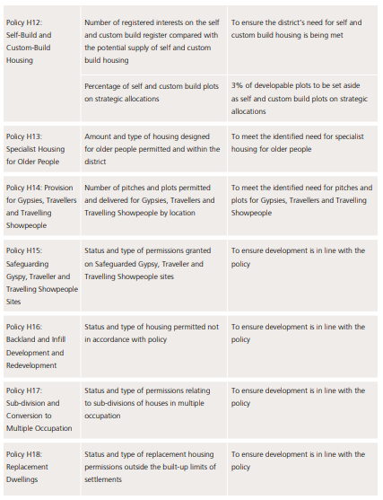

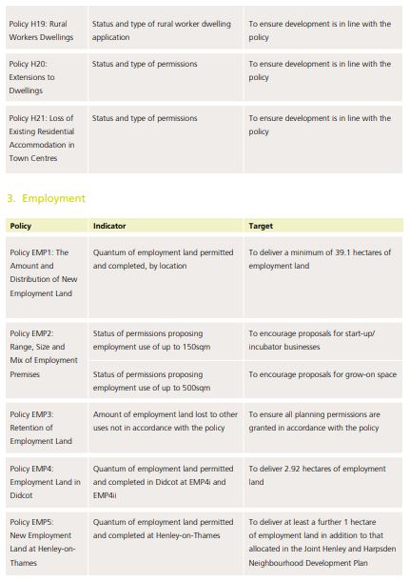

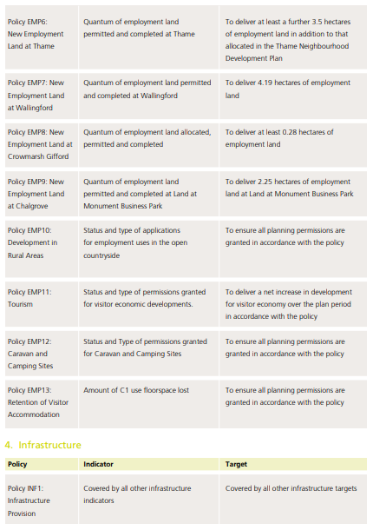

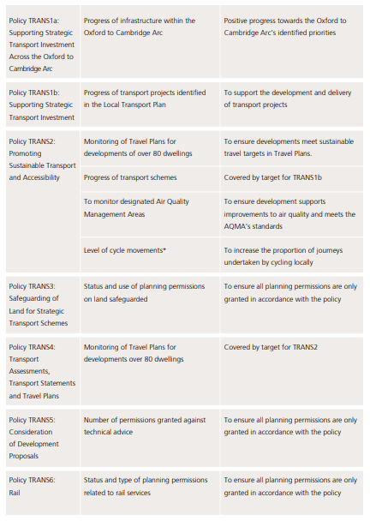

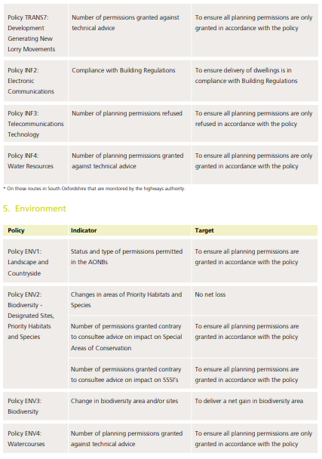

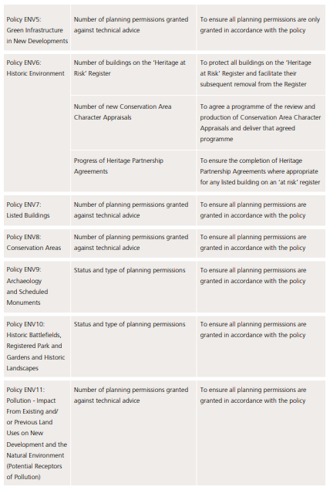

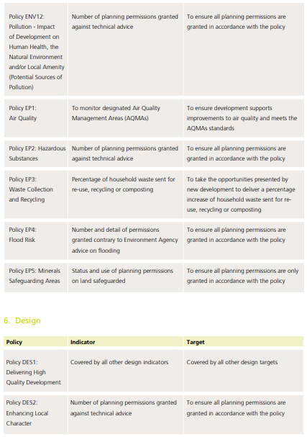

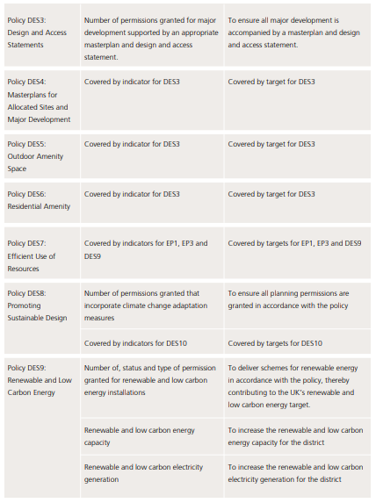

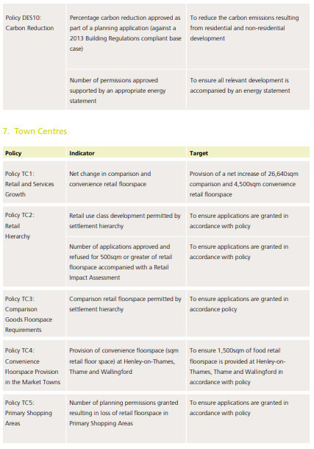

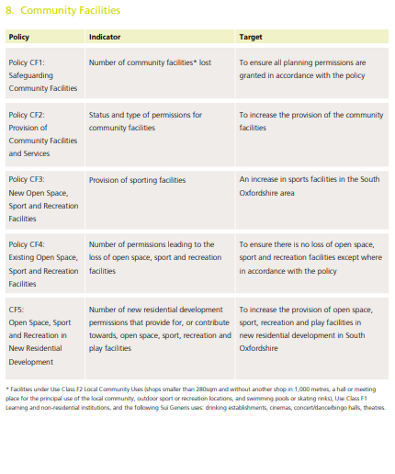

1. ODPM (2005) *A Practical Guide to the Strategic Environmental Assessment Directive*. Published September 2005.
2. EC (2001) *Implementation of Directive 2001/42 on the Assessment of the Effects of Certain Plans and Programmes on the Environment.* Available from <http://ec.europa.eu/environment/archives/eia/pdf/030923_sea_guidance.pdf> [Accessed June 2017].